

Advance visual programming
Theory Assignment

Submitted by :
Momna Rab Nawaz
232201021
Submitted to:
Sir Uzair Hassan

Dated:26-03-26
Assignment #1 – AI-Based Application Development in .NET (Theory)
1. Introduction to AI-Based Applications
- Definition of AI: Artificial Intelligence is the simulation of human intelligence processes by machines, especially computer systems, including learning, reasoning, and self-correction.
- AI-Based Applications: These are software programs that integrate AI models to perform tasks that typically require human intelligence, such as natural language understanding.
- Real-World Examples:
  - Chatbots: Like the KICSIT AI Assistant, which uses LLMs to provide study support.
  - Recommendation Systems: Used by Netflix or Amazon to predict user preferences.
  - Image Recognition: Used in medical diagnostics or autonomous vehicles.

2. AI in .NET Ecosystem
- Integration: AI is integrated into .NET through specialized libraries like ML.NET for local machine learning or via REST APIs to connect to powerful cloud models like Google Gemini.
- ML.NET: An open-source framework that allows .NET developers to create custom ML models using C# or F# without leaving the ecosystem.
- REST APIs for AI: Applications send HTTP requests to services (like the Gemini API) and receive intelligent responses in JSON format.
- Benefits of .NET: High performance, cross-platform support via .NET 8.0, and strong types which reduce errors during API integration.

3. AI Application Development Lifecycle
The development of an AI-based application follows a structured pipeline that ensures the final product is accurate, efficient, and scalable. For the KICSIT AI Assistant, the process followed these eight critical stages:

1. Problem Identification
This initial phase involves defining the "Why" behind the application.
- Concept: Identifying a specific pain point that AI can solve.
- Case Study: For this project, the problem identified was that Computer Science students at KICSIT often need immediate technical explanations or study assistance while working in their development environments. The objective was to create a lightweight tool that provides these answers without requiring the user to switch to a web browser.
2. Data Collection
Data is the foundation of any AI system.
- Concept: Gathering the raw information needed for the AI to function.
- Application: In an API-based project like this one, "Data Collection" involves identifying the vast datasets already pre-trained by Google into the Gemini model, as well as collecting local user inputs (prompts) that the bot will process.
3. Data Preprocessing
Raw data is often "noisy" or unstructured and must be cleaned before the AI can use it.
- Concept: Cleaning, formatting, and structuring data.
- Application: In the .NET environment, this involves "Prompt Engineering"—structuring the user’s text input from the WinForms text box into a format the API can understand. It also includes handling special characters or empty strings to prevent the application from crashing.
4. Model Selection
Choosing the right "brain" for the application is vital for performance.
- Concept: Selecting a model based on the balance of speed (latency), cost, and intelligence.
- Case Study: Initially, standard models were tested, but they led to quota issues. The Gemini 2.5 Flash-Lite model was ultimately selected because it provides the best speed-to-performance balance, ensuring the "KICSIT AI Assistant" responds almost instantly.

5. Model Training
- Concept: The process where the AI learns patterns from the collected data.
- Note for Report: Since this project utilizes a Pre-trained Model (LLM) via the Google Gemini API, the heavy training was performed by Google. However, "Fine-tuning" can be mentioned as a way to specialize a model for specific KICSIT course materials in future versions.

6. Model Evaluation
Before deployment, the model must be tested for accuracy.
- Concept: Using testing datasets to check if the AI gives correct and ethical answers.
- Application: This was performed by entering specific test prompts,
such as "hi gemini i am kicsit student," to verify if the model correctly identified the context and provided a helpful, relevant response.

7. Integration with Application
This is where the AI model meets the software code.
- Concept: Connecting the AI model to the user interface (UI).
- Application: The integration was achieved using the Google.GenAI SDK within a .NET 8.0 WinForms application. Using async/await logic in C#, the application sends user prompts to the cloud and displays the AI’s response in a RichTextBox without freezing the UI.

8. Deployment
The final stage is making the application available to users.
- Concept: Moving the code from a local development environment to a production-ready state.
- Application: The application was containerized using Docker, utilizing a multi-stage build process with the .NET 8.0 SDK and Runtime images. Finally, the source code and configuration were pushed to GitHub (Momina-debug/chatbot) for version control and distribution.
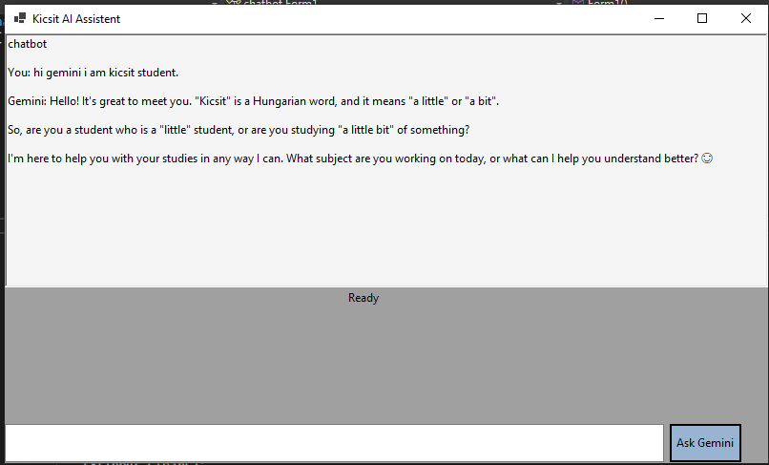

4. Architecture of an AI-Based Application
- Frontend: The Windows Forms (WinForms) interface where users interact with the bot.
- Backend: The C# (.NET 8.0) logic that handles asynchronous tasks and API calls.
- AI Model / API: The external "brain" (Google Gemini) that processes the logic.
- Database: (Optional) Used for storing chat history or user preferences.

5. API Integration Concept
- What is an API? An Application Programming Interface acts as a bridge between your WinForms app and the Gemini server.
- Request/Response Flow: 1. The client sends a "Request" containing the user prompt and an API key. 2. The API processes this and sends back a "Response" containing the generated text.
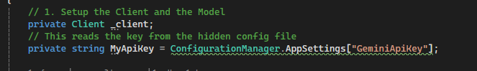

6. Introduction to Docker
- Definition: Docker is a platform that packages an application and its dependencies into a "container".
- Why use Docker? It ensures that if the chatbot works on your computer, it will work exactly the same on someone’scomputer without needing to install specific libraries.
- Portability: Containers can run on Windows, Linux, or the Cloud seamlessly.
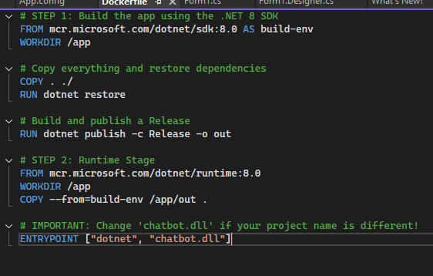

7. Version Control using GitHub
- Importance: It tracks every change in the code, allowing developers to "roll back" if a mess is made.

- Basic Workflow:
  - Repository Creation: Setting up a "home" for the project on GitHub (e.g., Momina-debug/chatbot).
  - Commit & Push: Saving local changes and uploading them to the server.
  - README File: A document that explains what the project is and how to run it.
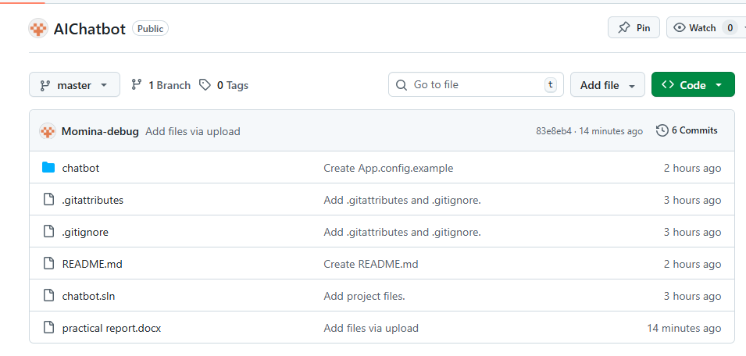

8. Ethical Considerations
- Bias in AI: AI models can sometimes inherit human prejudices from their training data; developers must test for fairness.
- Data Privacy: Protecting user information and sensitive data like API keys using tools like .gitignore.
- Responsible Usage: Ensuring the AI is used for educational support rather than harmful activities.

